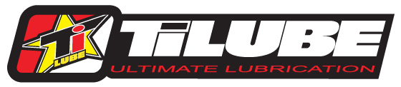

204 S Fillmore Street / Mount Ayr, IA 50854 / Ph. 641.464.3195

Rules of Eligibility

2016 TiLUBE Arenacross Contingency

1. Rider must purchase a Sponsorship Package which includes 2 quarts of oil of your choice, and one can each of Brake Cleaner, Chain Lube, Carb Cleaner, and Air Filter Oil. Choice of TiLUBE hat or T-Shirt all for 40% off of retail price.
2. Rider must have at least 2 visible TiLUBE logos on their bike, preferably on front fender arches, tip, or shroud. If on the shroud, logo must not be any smaller than 7 inches. Also must have a TiLUBE logo on jersey.
3. Must list TiLUBE as a sponsor at sign-up, press releases, and on the podium.
4. No conflicting sponsors at sign-up or on bike.
5. Must sign up at each event.
6. Only 1 reward per event weekend.